POWER BI

* Prepare Data in Power BI

1. Get data

* Get data from flat files -> csv, json, txt
* Get data from relational data sources -> sql
* Get data from NoSql
* Get data from applications
* Get data from analysis services - > web version of SSAS
* Get data from a dataflow

Get data> text/csv> data set> click open > load data, transform data

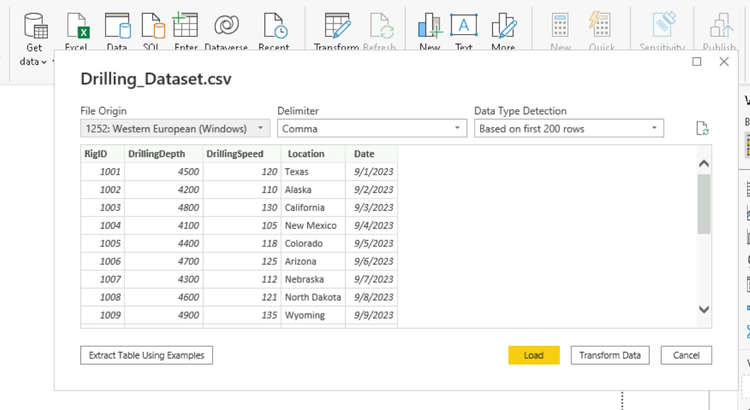

* Load data -> create a dataset -> tables
* Transform data -> navigate to power query editor -> shaping the data -> clean, perform de duplication, focus on maintaining the quality of the data
* Database
* **Import data** – **creating local (data set)** copy of data in power BI -> data set -> stores the information -> performance is dependent on the local data set that is created
* **Direct Query** – only create schemas -> connect directly to **data source** -> first compare the schemas created in power BI with data source schema and reads the data from there -> performance – data source from where we pull the data
* Analysis Service
* Import data – refresh operation is required
* Connect Live – direct communication -> if any change happens in the source, it’ll automatically update in power bi machine

1. Load data

Click on load> under data – drilling dataset> click> columns> date> hierarchy>

File>option& setting> option> global> data load> time intelligence>

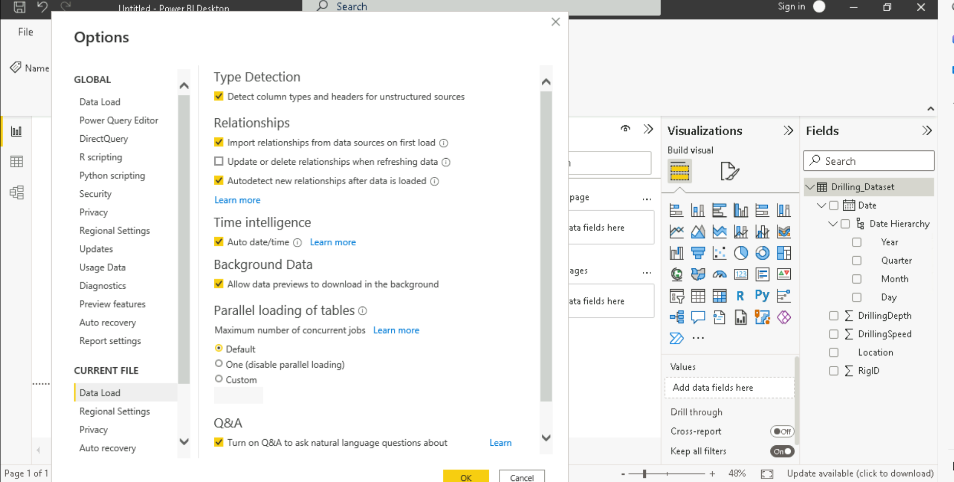

1. 3 views-> Report View, Data set view, Model view

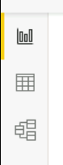

Report View – canvas to that we can use for visual designs

Data set view – we can explore the data to check the records

Model view – create relationships, modify columns, tables

Model> properties tab

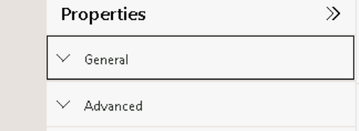

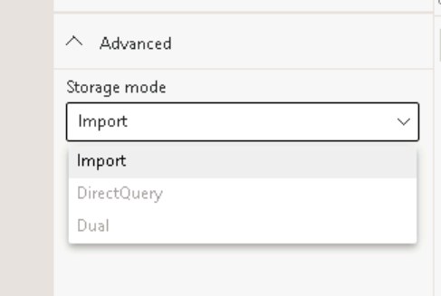

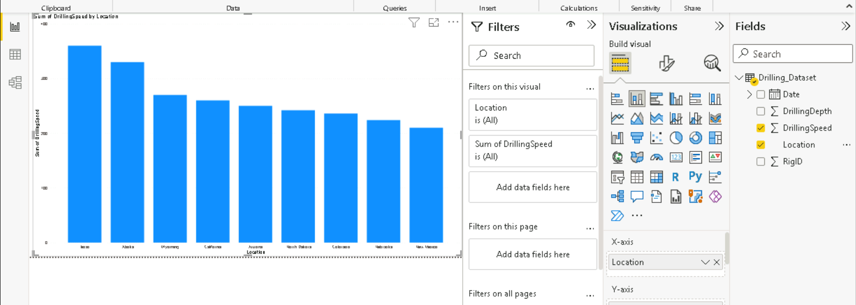

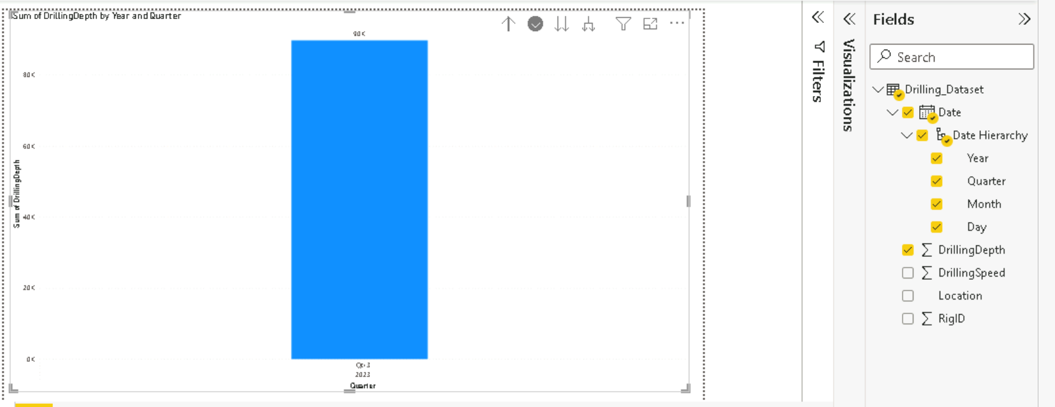

* Drill down approach – hierarchy
* Drill through approach – moving from one page to another/ one location to another, navigation



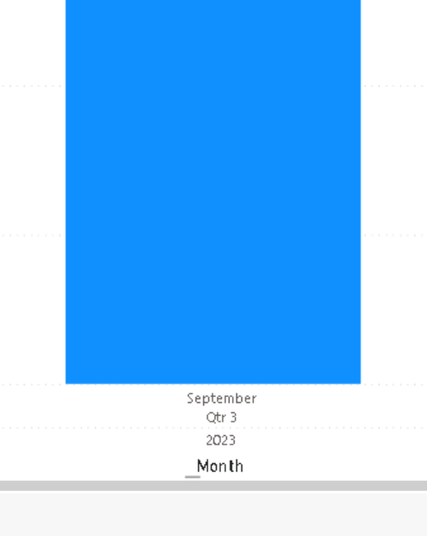



* Apply filters and visualizations

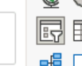 slicers – dynamic filters

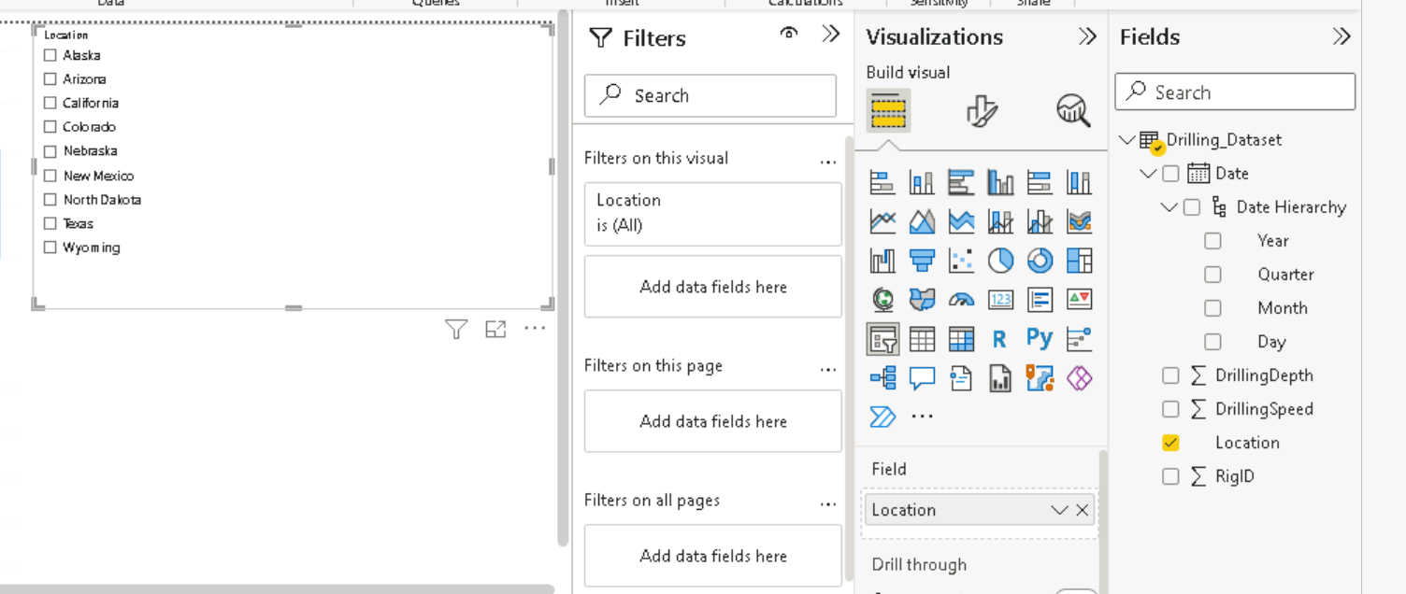

Multi selection

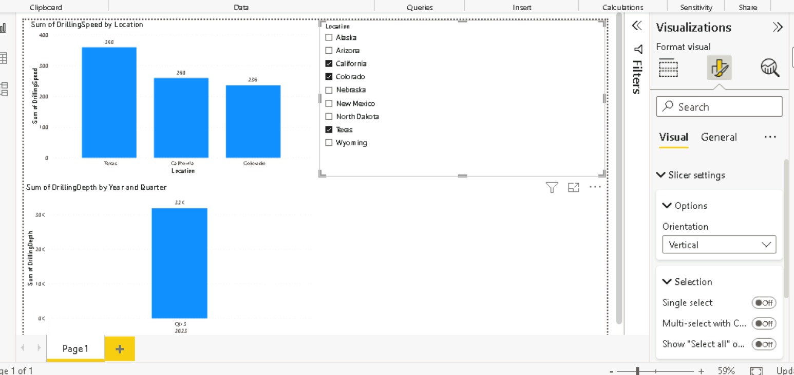

Creating groups

Adding columns

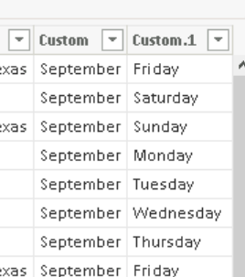

Creating & adding to hierarchy

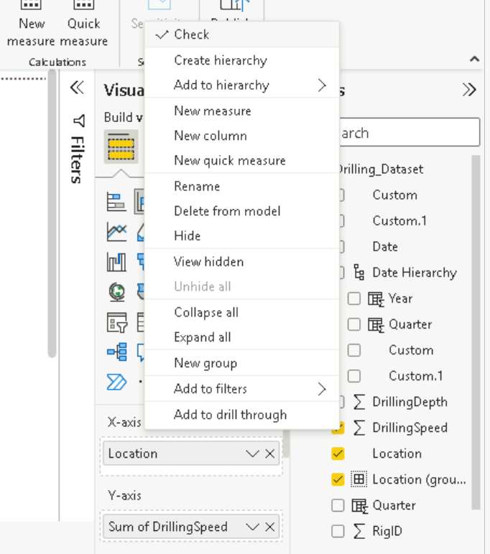

Find & Replace values

Cusid, cusname, gender, marital status, dob

New table upload and replace null with some value

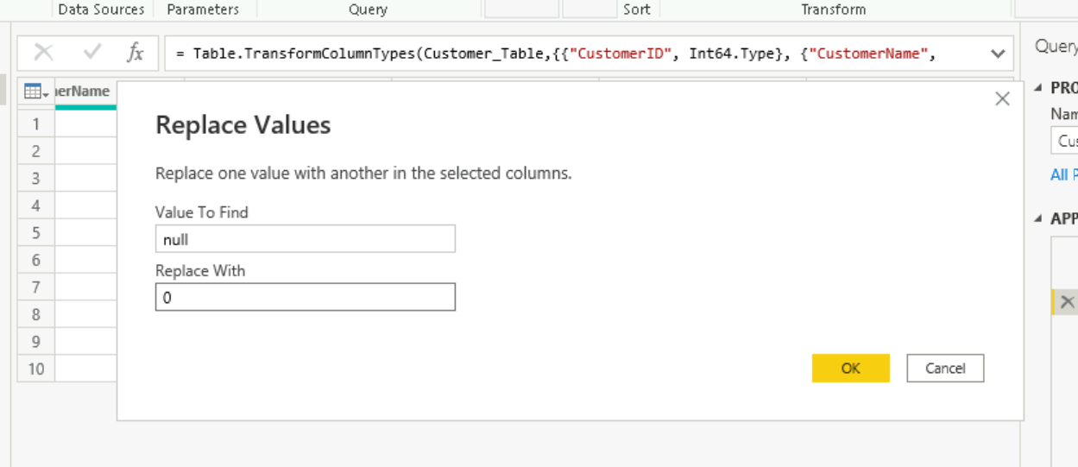

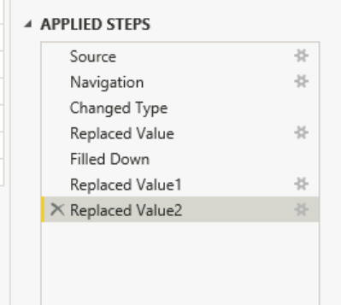

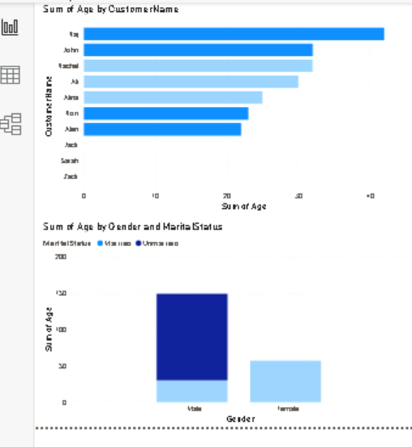

Working with dynamic input

Parameters: dynamic value that the user inputs

TASK:

1. Create fresh data source
2. Read csv data in Power BI

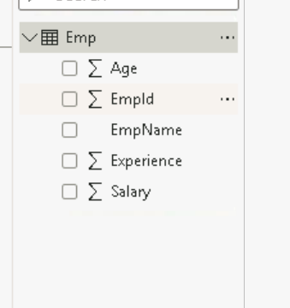

1. Try creating custom columns -> calculations – sum,avg,count

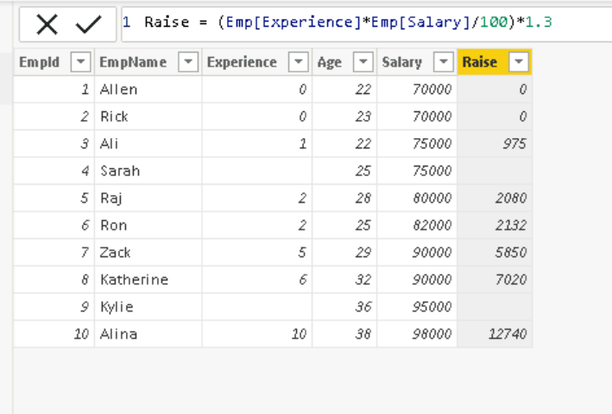

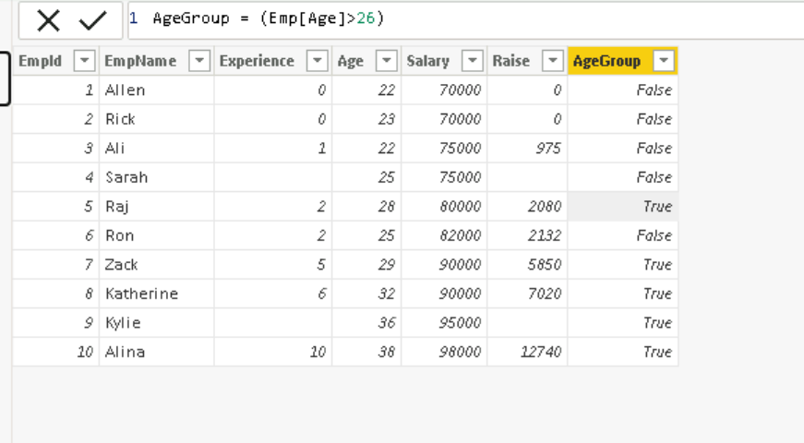

1. Replace null values with fill option

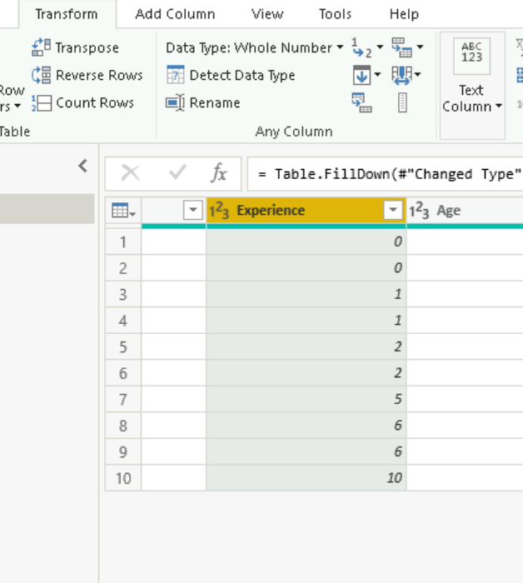

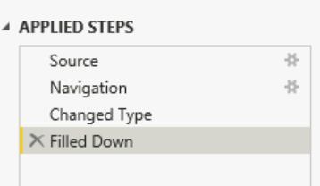

1. Create visualizations

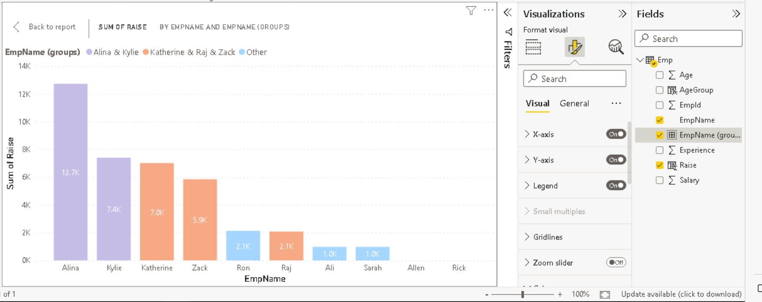

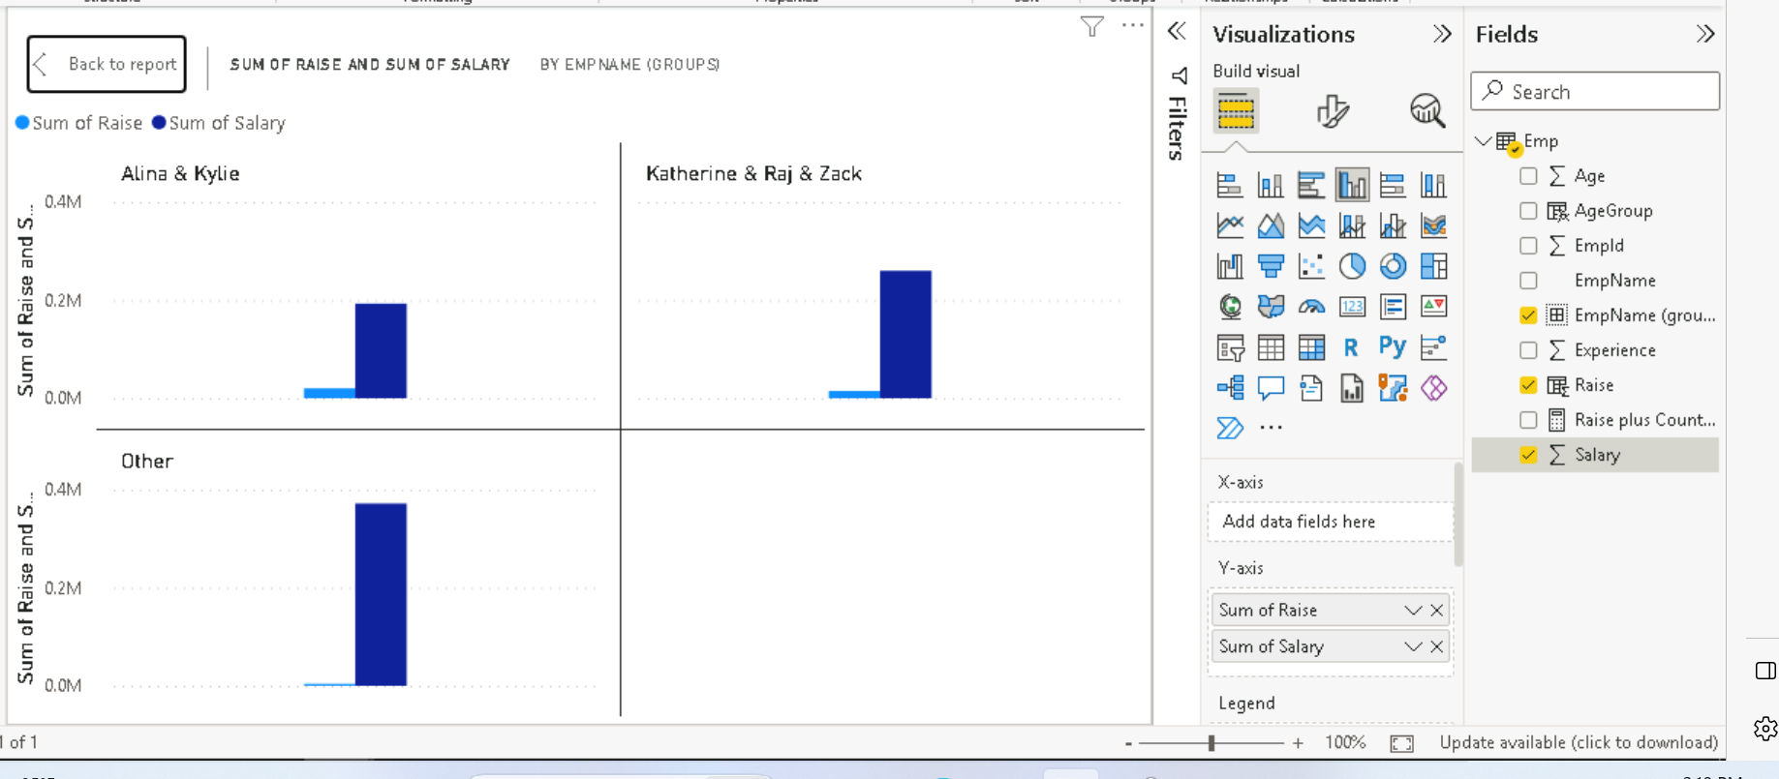

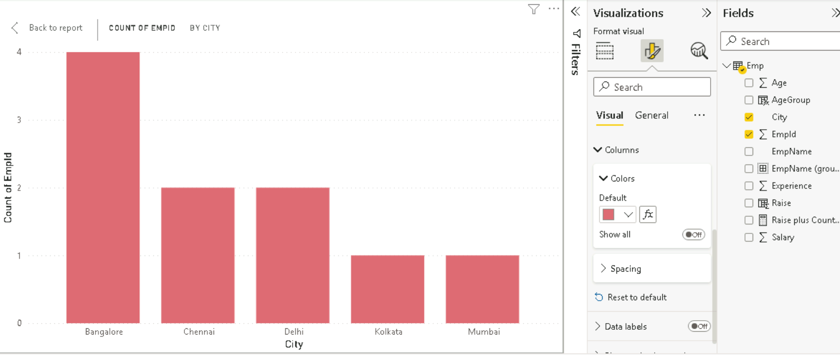

Customized columns

* Measures

1. Implicit -> no code required
2. Explicit -> manual code required

Calculate(expression,filter)

TotalSales=SUM(SALESDATA[SALESAMOUNT])

Required access –

R – Row

L – Level

S – Security

1. Static RLS -> manually give the values/conditions

Managing roles

1. Dynamic RLS -> userprincipalname() – capture user principal information

New table

DATATABLE

(

Custid, INTEGER,

DAY 2 – Power BI

* Create new measure

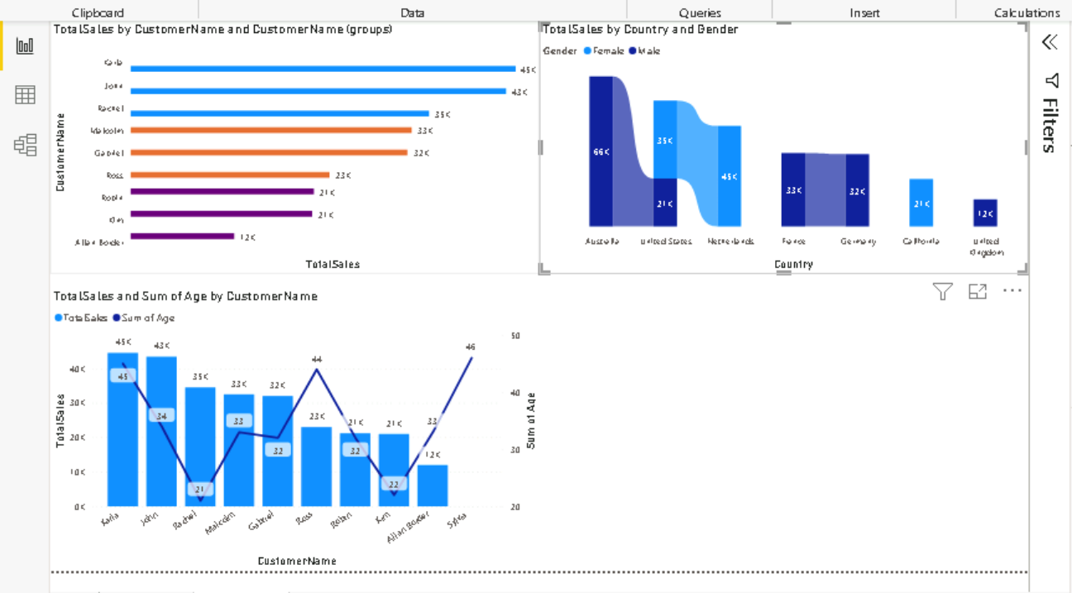

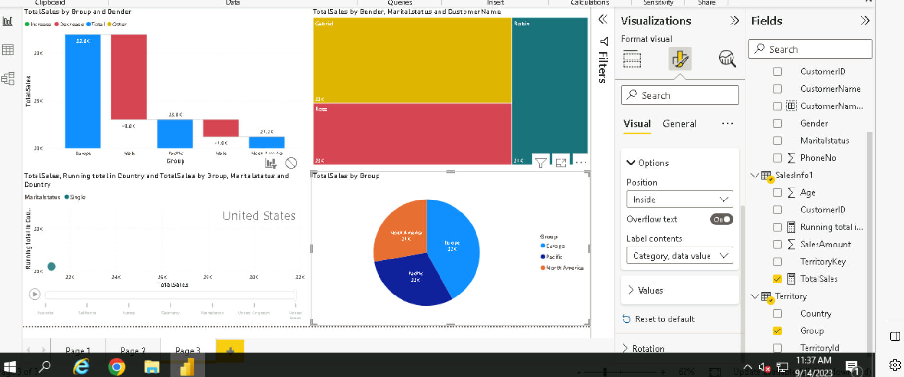

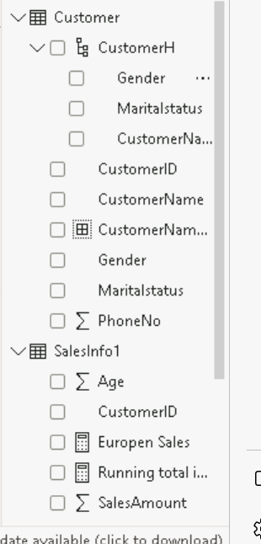

File>options> security> map &filled map visulas

* DRILL THROUGH

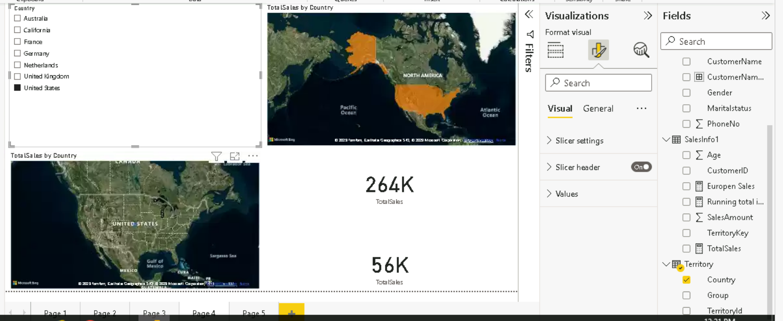

* Conditional Splitting

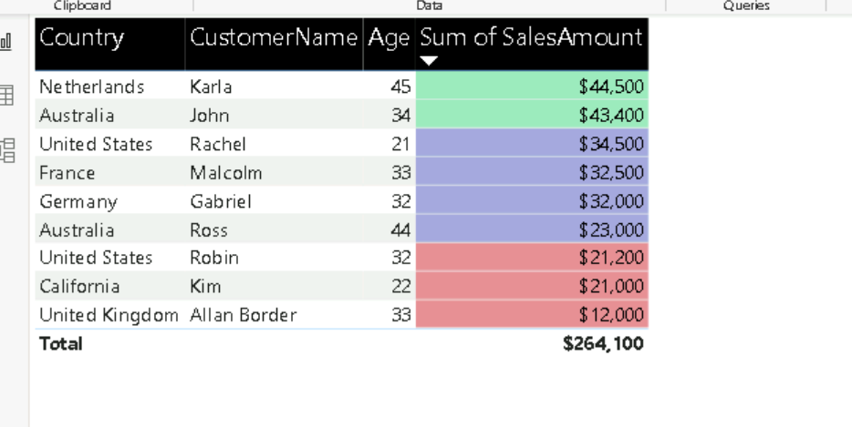

* SunBurst

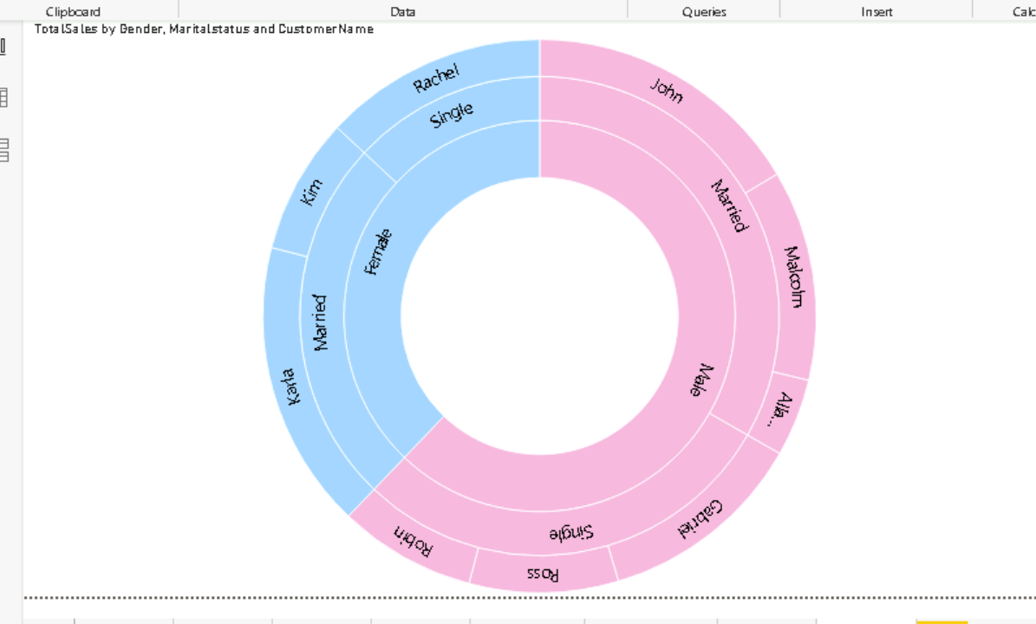

* Bookmark – single page, multiple visuals

Use customized buttons

Ctrl+button -> bookmark

Sales by country -> map

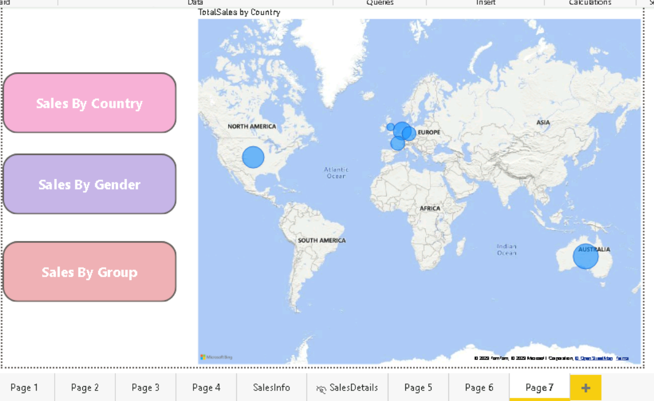

Sales by gender -> donut chart

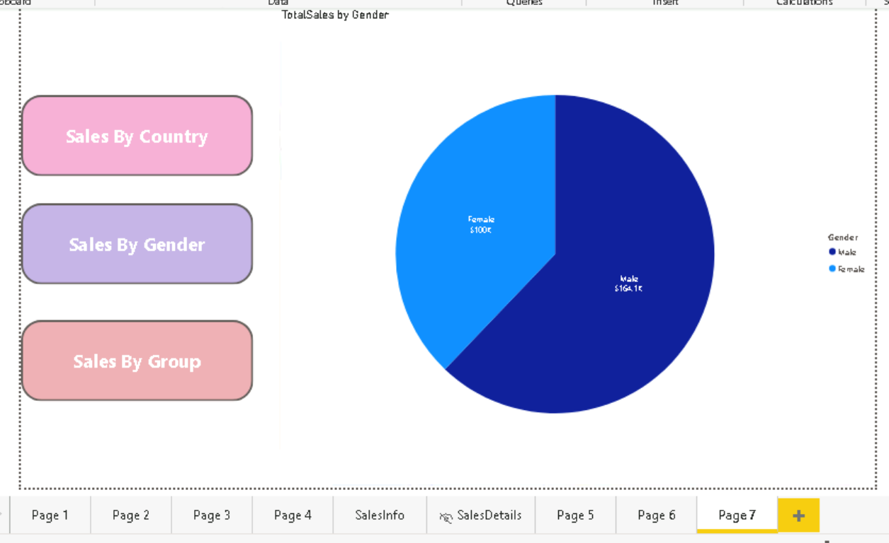

Sales by group -> bar chart

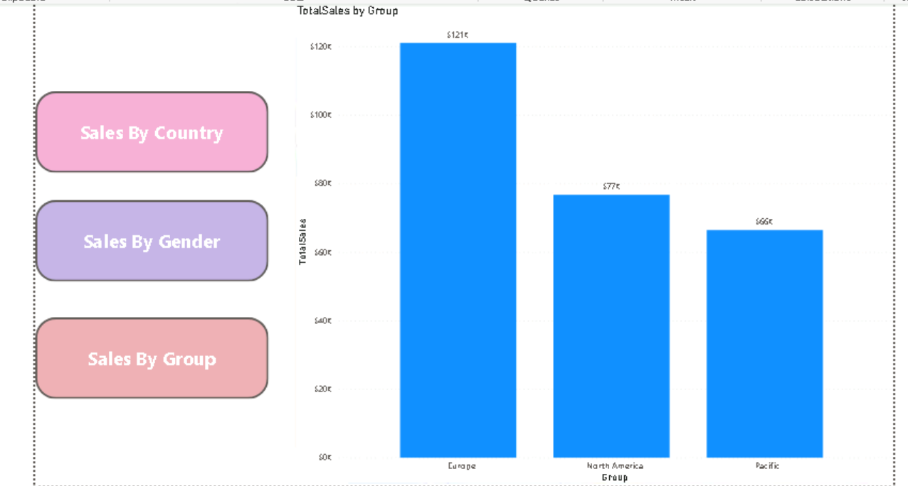

PYTHON

Get data>more>python>python script>paste the code

Load

Python script>expand the code editor> select all cols>within query editor

#Matplotlip

Import matplotlib.pyplot as

* Scatter plot
* Line Chart
* Bar Plot

Get data>more> python>python script>location where the file is> load the data

Q&A feature

Calendars

FiscalCalendar =

CALENDARAUTO(3)

ENGLISH CALENDAR

DateRange =

DATESBETWEEN(FiscalCalendar[Date],"1-1-2023","5-4-2023")